# ESP32 Key Features

* + Designed by EspressIf Systems
  + Dual Core
  + Wifi
  + BlueTooth
  + UltraPower Modes
  + Rich Peripherals(ADC,DAC,PWM,SPI,I2C,UART,CAN,Touch Sense,Half Touch Sense,SD Card Interface)

# ESP32 Development Boards

* + DevkitC V4
  + CAM
  + M5StackCore2
  + S3,C3,C6,H2
  + 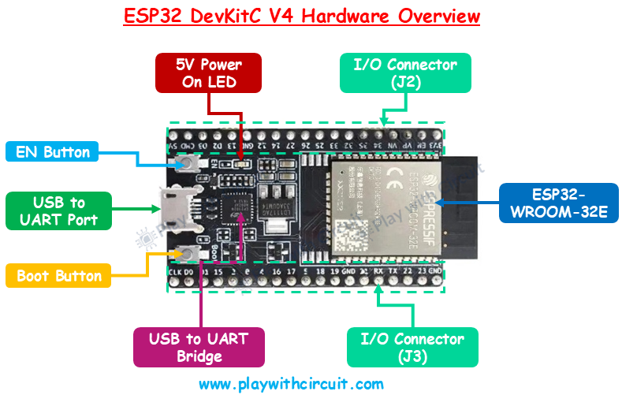

|  |  |
| --- | --- |
| WROOM-32E | dual-core CPU, 4 MB Flash, Wi-Fi + Bluetooth |
| **USB-to-UART bridge (CP2102N)** | programming and serial monitoring |
| **BOOT and EN (Reset) buttons** | flashing and resetting |
| **I/O header blocks (J2 & J3)** | breaking out GPIOs and internal peripherals (ADC, DAC, UART, I²C, SPI, PWM). |
| **Multiple power options** | USB, VIN pin (5–6 V recommended), or regulated 3.3 V input. |

# PinOut Diagram

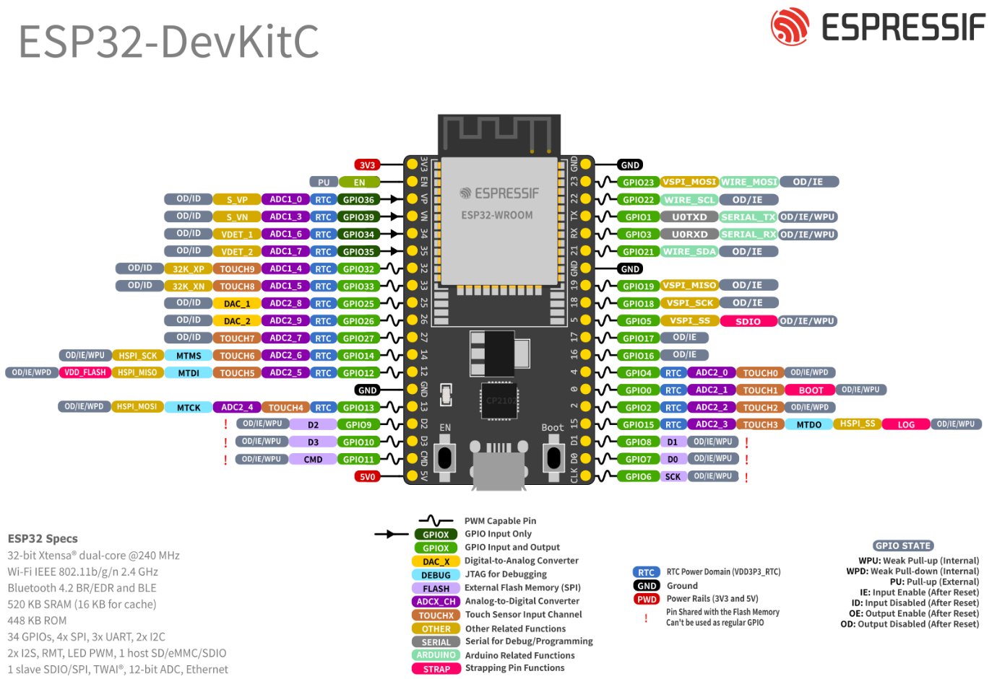

# How to Get Started

|  |  |
| --- | --- |
| Task | Design and Code |
| Blink LED | * How to change the voltage on the output pin? * How to work with time |
|  | * Packages needed are machine and time |
|  |  |
|  | * Machine package provides hardware related functions * Time packages provides “time” related functions |